SYSTEM DESIGN AND COMPONENTS
3.1-BLOCK DIAGRAM:
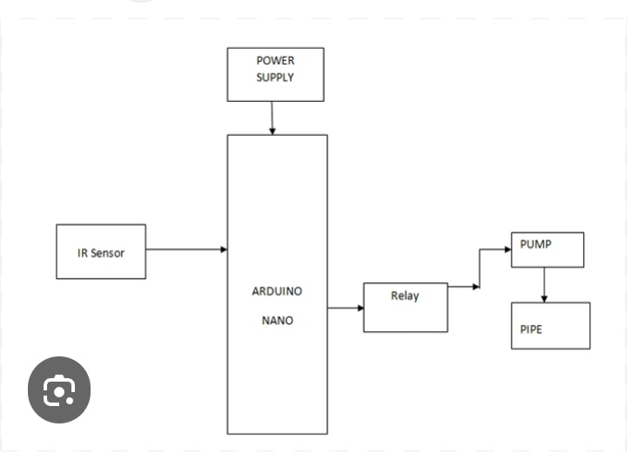

Block-by-Block Functional Description
- Arduino (interpreting data via code) or a Transistor circuit (acting as a physical hardware switch).
- Relay Module (Driver): Acts as an isolated electromagnetic switch. It uses the low-power 5V control signal to safely connect or disconnect the higher 12V power line.
- Power Supply: Converts mains AC or uses batteries to distribute 12V DC (for the solenoid valve) and 5V DC (for the sensor/control unit).
- IR Sensor Module (Input): Emits infrared light. If a hand reflects this light back, it changes its electrical output state.
- Control Unit (Processing): Receives the sensor signal. This can be an Solenoid Valve (Output Actuator): An electromechanical valve. When energized by the relay, its internal coil pulls open to let water pass through the tap.
3.2-COMPONENTS:
- Arduino UNO
- IR Sensor
- Single channel Relay
- Jumper wires
- Motor
- Pipe
Arduino UNO:
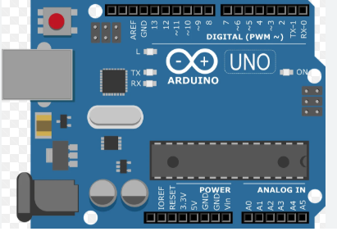

An Arduino Uno automatic tap using an IR sensor creates a touchless water dispensing system. The Arduino Uno acts as the brain: it reads the user's hand from the IR Sensor and switches a Relay Module to turn the water on or off.
• Detection (Input): The IR sensor continuously emits infrared light. When a hand is placedunder the tap, the infrared light bounces off the hand and back to the sensor.
• Processing: The IR sensor converts this reflection into an electrical signal and sends it to the Arduino Uno.
• Action (Output): The Arduino processes this signal. If a hand is detected, the Arduino sends a signal to trigger the relay module.
• Water Flow: The relay acts as an electronic switch, turning on a 12V DC water pump or a 12V Solenoid Valve to allow water to flow. When the hand is removed, the IR sensor detects nothing, and the Arduino commands the relay to shut off the water flow immediately.

IR Sensor:
It acts as an invisible electronic switch by continuously emitting and receiving infrared light. When your hands enter the sensing zone, the reflected light triggers a control module, which automatically turns the water on or off. An IR sensor module used in automatic taps typically consists of two primary electronic parts:
- Transmitter (IR LED): Continuously emits a beam of invisible infrared light outward toward the sink basin.
- Receiver (Photodiode): Waits to detect any of that light reflecting back.
The emitted IR light goes straight out and dissipates, so no light bounces back to the receiver. The tap remains closed. When you place your hands in front of the faucet, the infrared light hits your skin and bounces (reflects) back to the receiver.

When the relay is triggered, it opens the valve, allowing water to flow. When you remove your hands, the IR light stops reflecting back, the sensor cuts the signal to the relay, and the solenoid valve shuts off the water supply instantly.

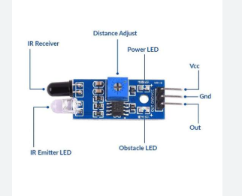

Single Channel Relay:
A single-channel relay is an electromechanical switch that allows a low-power signal (like a 5V output from an Arduino or Raspberry Pi) to control a high-power electrical device (such as a 220V AC appliance or a motor). Inside the module, there is an electromagnetic coil and a mechanical switch. When the microcontroller sends a small control signal to the relay's trigger pin, it activates the coil. This magnetism physically pulls the switch to open or close the circuit.
Control Side (Low Voltage/Logic): Usually a 3-pin header (VCC, GND, and IN/Signal). This is where you connect your microcontroller. Load Side (High Voltage/Power): Usually a 3-pin screw terminal block labeled COM (Common), NO (Normally Open), and NC (Normally Closed)

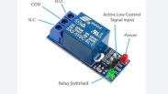

Jumper wires:
A jumper wire (or jumper cable) is a short electrical wire with rigid pins or connectors at both ends. It is used to connect different components in a circuit board—such as an Arduino, Raspberry Pi, or breadboard—without requiring any soldering.
• Male-to-Male (M2M): Features a pin on both ends. Used most frequently to connect two separate points on a breadboard.

• Male-to-Female (M2F): Has a pin on one end and a socket on the other. Ideal for connecting a breadboard directly to a component or a microcontroller
.
• Female-to-Female (F2F): Has a socket on both ends. Often used for pin headers on circuit boards (such as Raspberry Pi GPIO pins)

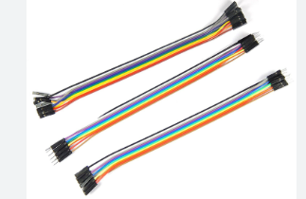
Motor:
Automatic tap using a DC motor is typically designed as a DIY project or smart-home retrofit. It works by combining a motion sensor (like an IR sensor) with a DC motor or 12V DC solenoid valve that automatically controls the water flow, providing a touch-free and water-saving mechanism. An Infrared (IR) or Ultrasonic Sensor detects your hand or an object placed near the tap. The sensor sends a signal to a microcontroller, such as an Arduino, or a simple relay circuit. The controller powers a DC solenoid valve (or a motorized ball valve), which opens the water line. When you move your hand away, the valve shuts off automatically, saving water

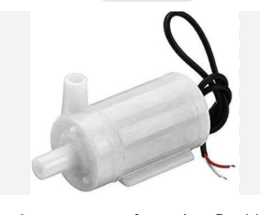

3.3-WORKING PRINCIPLE:
Automatic taps using IR sensors use infrared (IR) light to detect hands, signaling a solenoid valve to open instantly. When hands move away, the light beam is no longer interrupted, instantly cutting off the water flow.

Emission of Infrared Light
An IR transmitter (usually an LED) embedded in the tap constantly emits a continuous, invisible beam of infrared light into the space below the spout.

Detection (Reflection / Interruption)
When an object—like your hands or a washbasin—enters the detection zone, the emitted IR light bounces off the object and is redirected back toward the tap's IR receiver (a photodiode). (In some systems, the presence of the hands simply interrupts a direct beam).

Processing & Valve Activation
The IR receiver detects the reflected light and sends an electrical signal to the tap's microcontroller or control circuit. The control unit triggers a relay or transistor to send a current to the solenoid valve. The valve uses electromagnetism to pull open a diaphragm, allowing water to flow through the pipe.

Shut-off Mechanism
When you remove your hands, the IR receiver stops getting the reflected signal. The control unit immediately cuts the power to the solenoid valve, returning a spring-loaded seal to its closed position and stopping the water. Most taps also include a built-in safety timeout that automatically shuts off the water (usually after 30 to 60 seconds) even if hands remain in the sensor range. • To isolate the tap's light from environment noise, the transmitter pulses (modulates) its light at a specific frequency (typically 38 kHz). The receiver circuit uses a bandpass filter to block out any steady, unmodulated ambient light.

It consists of a coil wrapped around a magnetic plunger. When the control circuit sends power to the coil, it creates a magnetic field that pulls the plunger upward. This opens the waterway and allows water to flow. Shutting off: When you remove your hands, the IR light is no longer reflected, the control circuit cuts the power to the solenoid valve, and the plunger drops back down, instantly stopping the water.

